Can Student Travel Increase Knowledge Retention in the Classroom
Angelica T. Wilson
Clemson University
Research Project
ED 8600/8990
Research Project Professor, Dr. Luke Bennett
December 11, 2019
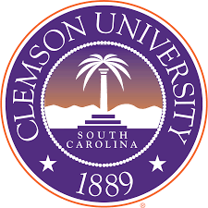

Certification of Authorship: I certify that I am the author of this paper and that any assistance I received in its preparation is fully acknowledged and disclosed in the paper. I have also cited any sources from which I used data, ideas, or words, either quoted directly or paraphrased. I also certify that this paper was prepared by me specifically for this assignment.

Signature: Angelica T. Wilson
Abstract
The purpose of this study is to determine the overall benefits of student travel and how short-term travel (8-20 days) can increase retention levels in students. The value of travel will be determined by J-Term survey results taken from student travelers who travel abroad for the duration of less than 20 days.

Can Student Travel Increase Knowledge Retention in the Classroom?
Introduction
The following literature review will cover the potential benefits or drawbacks of student travel. This proposal will cover how educational experiences, through travel, can give students a great idea of what is going on in their world. The subtopics of this proposal will be experiential learning—the process through which students develop knowledge, skills, and values from direct experiences outside a traditional academic setting, and abroad exchange programs—programs that allow students to travel for a certain time period, to other countries—while being able to experience cultural and educational opportunities that enrich their prospective—earning academic credit for their time spent in their chosen country/location.
There is something about students seeing and experiencing something firsthand as opposed to just looking at a picture in a textbook—ultimately, travel experiences make it easier for students to connect to topics introduced within a classroom. The excitement, visual stimulation, and first-hand experiences students come across, subsequently help students retain knowledge—overall promoting natural curiosity and interest in exploring their world. This study will aim to show the impact that student travel can have on student learning. Research will be conducted by evaluating students from a Christian school in the Upstate of South Carolina. For the safety of the students at this Christian school, the school name will remain private and will be called ABC Christian. ABC Christian school has students enrolled from Pre-K 2 to 12th grade. For the purpose of this study, the students that will be evaluated will be students in 8th grade-12th grade—students who are eligible to participate in J-Term. Within the upper school, there are 65 8th grade students, 83 9th grade students, 84 10th grade students, 87 11th grade students, and 86 12th grade students. Not all students will travel abroad for their J-Term requirements, however, all have the option to go on a trip or serve in an internship. ABC Christian is a predominately white school in the outer suburbs of a town in Upstate South Carolina. Students who participate in traveling in J-Term have typically traveled overseas before. Most ABC Christian School students are experienced in travel, however, most of them have never participated in a fully educational tour overseas. Teachers use various travel groups to take their students overseas—companies such as: EF Tours, Joshua Expeditions, Explorica, and EF America. All of the tour companies take an educational approach to their tours and students receive tours with guides who are masters in their content areas.
Literature Review
Experiential learning at its core, is the process of learning through experience, and is more specifically defined as learning through reflection on doing. Problem solving, decision making, communication, critical thinking, and collaboration are not merely skills to be learned in the classroom but experiences to be lived, and these lived experiences help engage us to become more flexible and integrative human beings. Student travel creates the ability to form deep connections with cultures and immerges the human mind into a world full of challenging and stimulating situations; situations in which one must think resourcefully and think differently. Abroad exchange programs allow students to experience things first-hand. Not only does traveling improve the understanding of cultures but it provides occasions for students to step into a world distant from their text books. Through student travel, students can take what is taught in the classroom and are able to apply their knowledge in specific settings—which allows students the opportunity to retain information longer, making them life-long learners.

Experiential Learning
According to Chow and Harfitt (2018), “There is broad literature on the provision of experiential learning (EL) projects in teacher education programs, but there is very little research on how to reliably understand the learning process or how to assess the process of change…” (Abstract, para. 1). The main purpose of this case is to provide an accurate account of how to elicit feedback from student teachers-- who accept the challenge of integrating experiential learning activities within their classrooms. Overall, Chow and Harfitt (2018) shed light on some of the most important aspects of the implementation of experiential learning and how to address key challenges that arise through a reflective process—which ultimately determines how learning experiences are evaluated. The case uses research findings from students who have engaged in the adaptation of experiential learning within their classroom—continuing the reflection component of the experiential learning process. Through the student finding and reflections data, it could be determined how to enhance the overall understanding on how to incorporate experiential learning in the classroom (Chow & Harfitt, 2018).
What serves almost as an extension to the article by Chow and Harfitt, David Kolb and Alice Kolb (2005) draw on the foundational theories of John Dewey and Kurt Lewin to examine the developments with the research and theory of experiential learning. They determine ways to enhance experiential learning—more specially in higher education. By introducing, the concept of styles and institutional environment, they illustrate the learning space framework in three cases within an institutional development (Kolb D., 2005; Kolb A., 2005). They consequently provide principles to enhance EL and how it can be applied in various educational environments and programs—such as longitudinal outcome assessment, curriculum development, student development, and faculty development.
Expanding on the two articles mentioned, Knut Petzold and Petra Moog (2017) discuss experimental learning-- but do so with an emphasis on studying abroad. Overall, they try to determine what shapes and influences the international experience. Their investigation aims to discover the causes of the intention for students to study abroad. By using the experimental approach and referencing multiple theories (Theory of Rational Choice & Theory of Planned Behavior), they determined that “the intention to study abroad is shaped by student’s evaluation of expected benefits from studying abroad, resources and restrictions regarding its realization, and normative aspects” (Petzold & Moog, 2017, p. 35). Against the growing globalization of the economy, studying abroad is frequently regarded as a beneficial opportunity that provides students with language skills, and intercultural competence—which can be beneficial to their marketability in future employment.
Abroad Exchange Programs
Several articles within this subtopic will focus on the factors associated with student participation with traveling abroad as well as how traveling can influence a student’s engagement and overall retention levels. Overall, the Journal of Studies in International Education focuses more on the factors associated with student participation in studying abroad. The main objectives of this specific research was to identify factors that assisted or deterred the development of international student exchange programs (Doyle et al., 2010). The researchers conducted student surveys and interviews participants who were randomly chosen students who have participated in studying abroad. The survey’s focused on students’ knowledge of and attitudes towards studying abroad. The results of the surveys and interviews (conducted for research) concluded that exchange programs were most effective when word of mouth could be reinforced by effective brochures, websites, and efforts from liaison officers, lecturers, and international program staff members that help students through the abroad program. In correlation with the effectiveness of support throughout the abroad program, they keyed on stating the perceived benefits of overseas exchanges. “Among respondents, the most important benefit from studying overseas was the expose it would provide to a different culture and language, followed by the chance to see whether they would like to live and work overseas…” (Doyle et al., 2010 p. 478).
Within Christy A. Metzger’s research on studying abroad, she focuses on the concept of studying abroad being a 21st century retention strategy. Recognizing that it has become increasingly important for members of the workforce to hold a bachelor’s degree, she states, “today few would question that to be competitive at the postsecondary level and in the workplace, international awareness, exposure and language training are truly advantageous” (Metzger, 2006, p. 164). This quotation shows the underlying value of the type of exposure employers are looking for within their employees. Within her general research related to retention, The Office of Policy Research at ACT conducted 109 retention studies of full-time students at 4-year institutions—trying to determine the factors behind students staying in school. The studies show that universities that “take an integrated approach to retention efforts that incorporates both academic and non-academic factors into the design and development of programs to create an inclusive and supportive academic environment” will have a higher number of students who stay in school (Metzger, 2006, p. 166). Metzger, then continues to speak specifically of the study abroad research—in which she states sources that recommend that institutions should develop programs that will positively affect the social and intellectual opportunities for all (especially minority) students (2006, p. 167). Research on international education studies have found that students who participate in these programs have lasting effects across their academic and social growth—improved self-confidence and self-efficacy being regular listed as these positive outcomes.
In continuation with the subtopic of studying abroad, authors Richards and Wilson (2003) go into depth on how students (within our modern society) equip themselves for a growing global society. As societal support for the value of student travel is increasing, educational institutions must be able to provide successful programs in which students are able to experience the growing niche of the student travel market (p. 2). The aim of their research is to gather consistent and detailed information on the traveler—while combining and taking into consideration the social and cultural aspects of the young travelers themselves. Responses were drawn from 2,300 students who have traveled abroad to Canada, the Czech Republic, Hong Kong, Mexico, Slovenia, South Africa, Sweden, and the UK. As students returned home, they were asked questions that detailed the main benefits from their travel and well as the cultural benefits they were able to experience. Connections in this study were also made between youth and student travel and the potential for creating a culture of peace and non-violence among young people (Richards & Wilson 2003, p. 12). As both authors go into the multiple facets behind what influences young people to travel, one cannot dismiss the motivation behind student travel is to explore other cultures while seeking experience and newfound sociability.
Authors Stebleton, Soria, and Cherney (2013) discuss the number of students participating in study abroad programs is beginning to rebound due to renewed student interest in global current events and gaining global and intercultural communication skills (p. 1). Since most colleges and universities around the United States have put a strong emphasis on having their students global minded, study abroad programming is often the primary way students achieve that goal. Their research strives to examine how different abroad experiences influence the development of a student’s global and intercultural competencies. The article mentions several smaller studies that substantiate the extended benefits of study abroad programs on student engagement. It was discovered that studying abroad has a positive impact on student development and increases level of engagement (Stebleton, Soria, & Cherney 2013, p. 5). The authors ultimately concluding, after administering a survey to 287,498 undergraduate students across twelve large public universities, with provided evidence, that study abroad provides education benefits to students regardless of their backgrounds, educational aspirations, or college experiences—students who study abroad have greater intercultural proficiency, cultural diversity, and are more globally minded that their peers who stay on campus.
Authors Stone and Petrick (2013) also show the education benefits of travel experiences within their literature review. Through empirical evidence and conducted student surveys, they mention outcomes of travel and the educational benefits shown within various forms of literature about study abroad programs (p. 1). As their research primarily focuses on young adults and college students, they mention the inclusion of the educational outcomes of domestic travel, youth travel, and consequently determine which travel experiences result in the most learning benefits. Within the review of literature, authors stone and Petrick mention that, “because of the difficulties in defining learning, the terms education, learning, and knowledge, and educative outcomes are used interchangeably in this article (2013, p. 2). The authors continue with the thought that the principals of experiential learning provide a model that explains how people learn by traveling—learning through experience.

Literature Review Summary
The studies mentioned above provide specific guidance into the potentiality behind how student travel positively affects students in and out of the classroom. The articles not only focus on how traveling falls into the category of experiential learning, they also go in depth on study abroad programs and how they provide educational benefits to traveling students. “International student exchange programs are widely promoted in higher education as a means of developing desirable intercultural skills and understanding among students” (Doyle et al., 2010, p. 471). While the articles do not mention research on domestic travel, such as field trips and excursions, the related subjects can still fall into the category of student travel—especially since most field trips do have strong learning components embedded into its foundation. David and Alice Kolb (2005) integrate the importance of experiential learning into high education—as there are, “recent efforts to improve high education (Kolb D., 2005; Kolb A., p. 193). As most articles do focus on the cross-cultural competence that traveling may provide, they also place importance on personal change instead of just placing sole focus on stringent learning outcome/objectives. Throughout time, travel has been considered educational. “Travelers have undertaken journey’s in order to learn, and people still refer anecdotally to the education benefits of travel. Yet there is a belief among many that education happens primarily in the classroom, even though learning can occur in many contexts, including travel (Stone & Petrick 2013, p. 11)
Purpose of Study
The purpose of this study is to examine the overall affects that traveling overseas provides to students’ retention capability. By building on student opinions after traveling, results from conducted surveys, and first-hand observations of students traveling, this study will investigate how travel affects a student’s retention potentiality. This study aims to determine how travel can extend what students learn in the classroom by the implementation of experiential learning.
Traveling overseas brought a newfound perspective on my life and knowledge. In college, I was able to experience my first international trip to Africa, and it was during this trip that I fell in love with everything that traveling abroad has to offer. From my personal experiences with experiential learning, cultural immersion, and overall confidence building--traveling abroad provided me with learning experiences that are simply difficult to recreate within the confines of a classroom.
Ever since I became a teacher in 2011, I have wanted to provide my students with the opportunity to travel overseas (or domestically) to deepen their commitment to learning. Since I have led various trips overseas, I have always wanted to conduct a formal study that focus on how student travel can enhance not only their cultural experiences but also increase their retention of what has been taught in their classrooms.
There is something about students seeing something firsthand as opposed to just looking at a picture in a textbook—which ultimately makes it easier to connect to the topics introduced within a classroom. The excitement, visual stimulation, and first-hand experiences help students retain knowledge—overall promoting natural curiosity and interest in exploring their world.
Research Questions
The research questions for this study are:
- What are the characteristics of student travel that stimulate student success and academic retention levels?
- What is the relationship between student travel and confidence levels in and out of the classroom?
Method
This research plan will go into detail on who the participants will be, and it will also describe the overall setting of the study. Next, the study will then describe the procedures and measurement tools that will be used throughout the duration of research. To conclude, a timeline will be included to outline the time and overall expected stages that will be taken throughout research.
Participants and Setting
The school used for the purposes of conducting this research will be ABC Christian School in the Upstate of South Carolina. ABC Christian is a K-2-12th grade school and have students from the age range of 2 years old to 18 years old. For the purposes of this study, however, the participants will be from the age range of 14-18 years old—only students who can participate in J-Term, an extended week where students can go on a trip or participate in an internship that matches what they can anticipate majoring in on their road to higher education. As of August 29, 2018, ABC Christian School student body contains 63 African American students (6.00% of the student population), 38 Asian students (3.62% of the student population), 33 Bi-racial students (3.14 of the student population), 851 Caucasian students (81.05% of the student population), 37 Hispanic students (3.52% of the student population), 2 Native-American students (0.19% of the student population), 13 students who maintain ‘no preference’ on student records (1.24% of the population), and 13 students who fall into the ‘other’ category (1.24% of the student population—totaling at a total enrollment of 1050 students.
ABC Christian School J-Term is a one-week, intensive, experiential learning program in which ABC Christian School students are challenged to take their classroom learning to the next level. The purpose of this dynamic and relevant aspect of the ABC Christian curriculum is life transformation and extension of the classroom, while giving students an opportunity to bond with faculty and peers outside the traditional classroom environment. A variety of experiences are available, and students are encouraged to choose one that fits their overall goals and aspirations for the future. Students have an opportunity each year to participate in one of the following:
- Domestic or International Trips
- Classroom Experiences
- Internships
One quarter (1/4 academic credit is earned for ABC Christian School J-Term Experiences each year. This is an academic requirement for graduation at ABC Christian School.
Students who will participate in J-Term will be determined on February 21, 2019. The numbers can vary depending on which students (8th-12th grade) want to sign-up for a summer 2019 J-Term or winter 2020 J-Term experience. Below are the following J-Term trips outlined for summer 2019 and winter 2020:
Summer Trips
- Scuba in the Keys
- Atlantic Canada’s Coastal Wonders
- The Carolinas—Hurricane Relief
Winter Trips
- France
- Missions: Snorkel and Serve
- Disney Youth and Education

Procedure
As previously stated, the number of students who participate in J-Term will vary, depending on the number of students who sign up for a J-Term trip—whether overseas or domestic. The students will vary from 8th to 12th grade and will be taking an online (electronic) survey before departure that will determine their thought of the benefits of student travel and education within a classroom. All questions and observation of students will require the consent of the superintendent, Dr. Barfell, as well as the upper school principal, Dr. Stouffer. Along with administration consent, parents, students, and teachers will also be given an informational form introducing the research plan in which they ultimately have to sign in order to participate in this research study. The survey questions will be unbiased and will vary—allowing students to be honest with their opinions which will ultimately help set the standard for the direction of the research plan. Participants will be mandated to take this survey as J-Term counts as a graduation grade. Teachers leading trips overseas will also be taking a survey that will determine their worldview of student travel.
Once students return from their trips, the same survey (taken before departure) will be conducted that will ask the same questions—determining whether their perspectives have shifted or stayed the same. Students will be ultimately graded based on a rubric that will be attached to this study along with a one-on-one meeting with the leader of the trip to discuss their overall involvement and to receive general feedback about their experiences. The data collected from the participants will then help determine student perspectives and the overall benefits of student travel. The researcher will also receive assistance from other teacher trip leaders to gain information on student behavior and overall experiences they had throughout the duration of their trip.
The results of projected students who participate in a J-Term trip will be anonymous and will be identified with letter identifiers. The study will consequently disclose the potential benefits of student travel as well as any other information that arises throughout this study.
Materials/Instruments
As stated above, students will be surveyed before and after their trip experience. Along with survey information, data will also be collected from overall student involvement as well as their behavior while on their prospective tours. The surveys will contain various questions that will help determine student perspectives of travel and the benefits or drawbacks they believe are associated with traveling. The before and after survey (taken electronically) will help determine how students’ perspectives may or may not change (depending on original results) and will provide an accurate indication of student travel as they will be able to experience it first-hand. A general J-Term rubric will also be used alongside one-on-one interviews to determine student involvement while on their prospective trips—where their grades will be determined by their prospective trip leaders.
Timeline
Before Travel | During Travel | After Travel
Student will take a mandatory survey that will determine their overall perspectives of student travel | Trip leaders will be taking observations of students while traveling and throughout their experiences. Their notes will add onto the information the surveys may provide. | Students will have an interview with their trip leader where responses will be recorded by trip leader (airport meetings on the way home). After they have returned home, students will take the same before travel survey to determine whether their perspectives have changed or stayed the same.

Results
The results of this study show the various perspectives students have about short-term international travel. Through various question types, i.e. short response questions and multiple choice questions, students were given the opportunity to determine how their short term travel experiences affected their lives.
The following tables indicate how students answered various questions in regard to their travel experience.
Figure 1
In figure 1, 66.7% of students had never participated in a J-Term experience and 33.3% of student had.
This is my first year participating in a J-Term
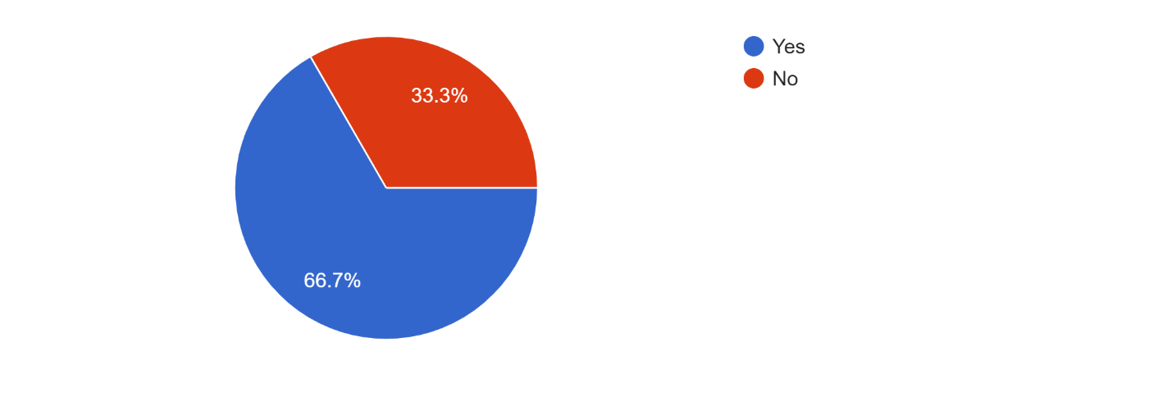

Figure 2
In figure 2, 66.7% of students strongly agreed at the thought of their J-Term experience being an academic growth opportunity while 33.3% of student agreed with the statement.
The J-Term experience was an academic growth opportunity
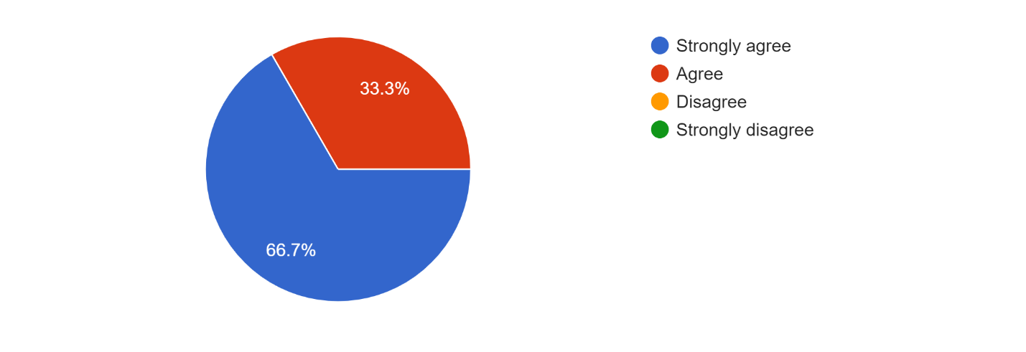
Figure 3
In figure 3, 66.7% of students strongly agreed on their J-Term experience provided them with an opportunity to grow personally while 33.3% of students agreed.
The J-Term experience provided an opportunity to grow personally
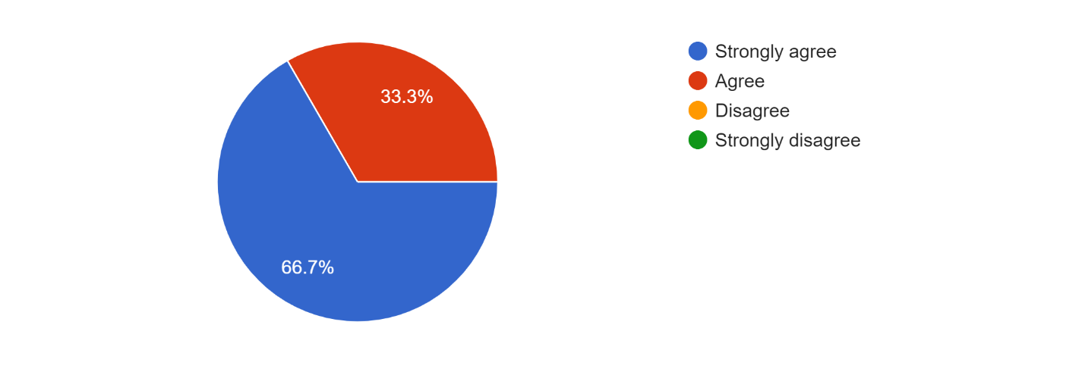

Figure 4
In figure 4, 66.7% of students strongly agree that travel can help determine what you want in life and 33.3% of students agreed with the statement.
Can travel help determine what you want in life?
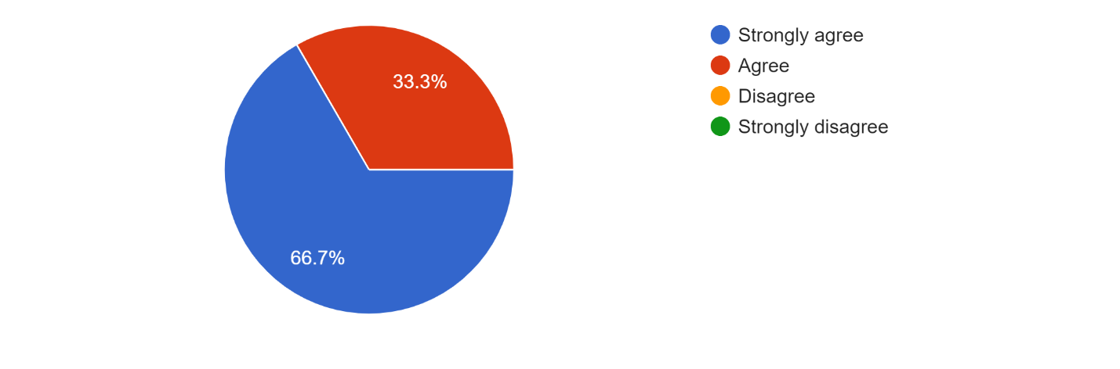
Figure 5
In figure 5, 66.7% of students strongly agreed with the statement that travel can help you determine what you are passionate about while 33.3% of students agreed.
Can travel help you determine what you are passionate about?
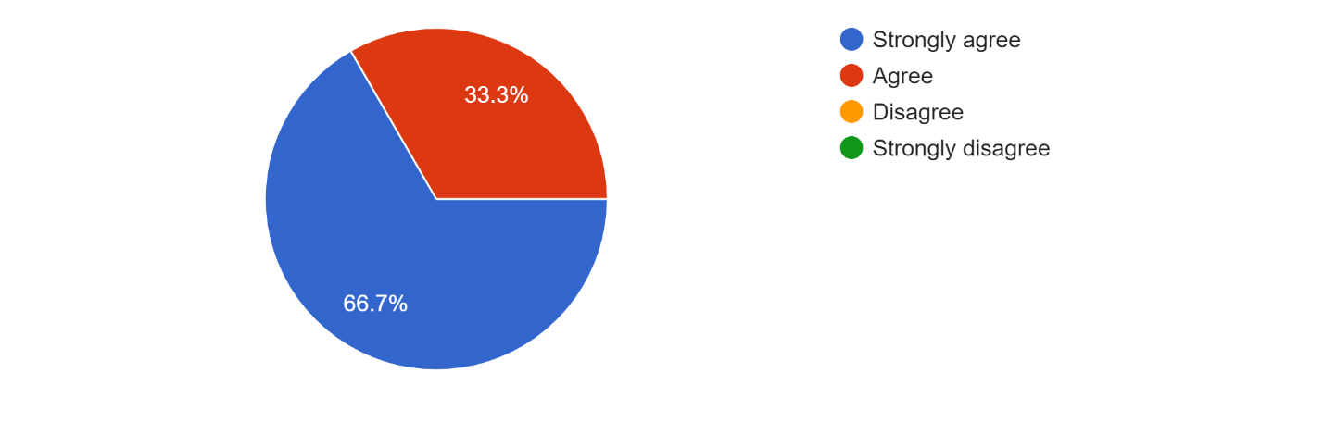

Figure 6
In figure 6, 100% of students strongly agree with the state that travel can help you learn more about the world.
Can travel help you learn more about the world?
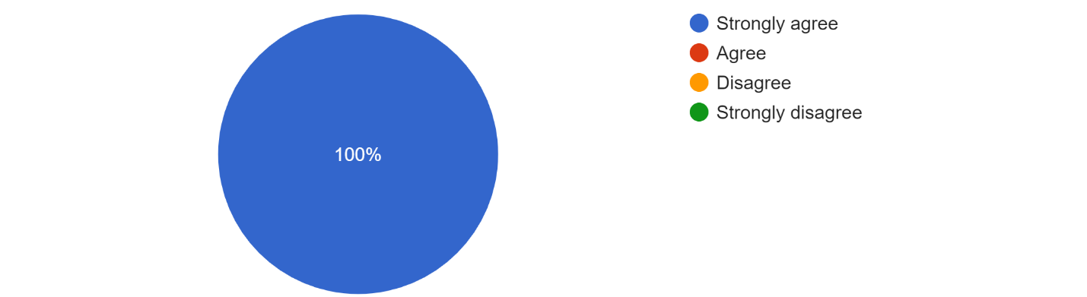
Figure 7
In figure 7, 66.7% of students strongly agree with the statement—travel can help you improve how you react to difficult situations while 33.3% of students agreed.
Can travel help you improve how you react to difficult situations?
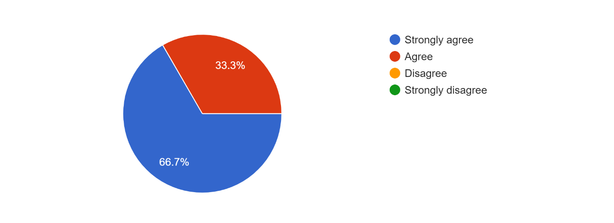

Five students, varying in age—were interviewed and were asked separate questions that prompted a longer response than a multiple choice question. Overall, there were several themes that arose from the interview question answers. Based on the student’s responses, there was an overwhelming sense of thankfulness for their experience. They all understood how traveling in itself is a luxury that many are not able to afford. One student mentioned that a specific drawback of traveling abroad is the cost and that is one of the main reasons why people aren’t able to see the world. Students also understood the overall benefits of traveling abroad—especially learning and experiencing things taught in the classroom firsthand. Student C states,
“I think you are able to empathize better with people and you can learn more and take the things you learn in the classroom and put it into something that is vivid. When I went to Austria and we went to the Hapsburg home we were learning about the Concert of Vienna and everything I was learning in the classroom was reinforced by my experiences. Something clicked for me--being able to experience something in person that I was learning in the classroom.” Generally, students that were interviewed saw and valued things about traveling overseas for a short duration of time. Even though students did not spend a lot of time in their specific country, they were able to learn, experience, and appreciate aspects of their trips in their own personal ways.

Conclusions/Discussion
The overall purpose of this study is to examine the overall affect that traveling overseas provides to student’s retention (the power or ability to keep or hold something in memory) capability. The retention of students was something that could not be measured specifically, however, based off the survey questions and data, students were able to vocalize—without being prompted, how learning something firsthand, after learning it in the classroom solidified their understanding of the content. The majority of students, as seen in the results section, shows all students surveyed either strongly agreed or agreed to the following questions:
- The J-Term experience was an academic growth opportunity.
- The J-Term experience provided an opportunity to grow personally.
- Can travel help determine what you want in life?
- Can travel help you determine what you are passionate about?
- Can travel help you learn more about the world?
- Can travel help you improve how you react to difficult situations?
These range of survey questions were meant to have students think about their traveling experience to determine how it affects their everyday lives.
The interview questions were designed to supplement the survey questions and to allow more room for conversation—having student’s breakdown their thoughts in a more defined response that indicates concrete examples for their experience in short-term educational travel. The results overall, solidified how experiential learning is extremely beneficial to students. Learning through experience, allows students to problem solve, make decisions, and communicate, growing their capability to experience things beyond the four walls of a classroom. By being immersed in a culture other than their own, allows students to connect to these cultures—which ultimately provides them with firsthand experiences they can apply to future scenarios in which these experiences will be valuable.
The results of this study showed how incredibly valuable traveling can be for any student. Not only did students show throughout their responses how traveling provides them with memories that would last a lifetime, it also provides them with invaluable experiences that are ultimately priceless to their lives.
Implications for Practice
Teaching in both public and private schools, I have seen firsthand the struggles that all students face—the mundane routine of learning within the four walls of a classroom. Teachers can vary in skill and can vary their lessons to ultimately allow students the opportunity to become intrigued and involved in the content, however, learning through experiencing—seeing something firsthand, is a type of learning you can simply not replace. Students in the 21st century want to be entertained and constantly intrigued and are not afraid to tell you otherwise. The constant battle a teacher faces every day—capturing and maintaining the attention of their students, is one that many are not able to overcome.
Despite all that seems to be going against us, I have had to find something that works for me, my students, and my school district: experiential learning—through travel. I have personally found a high amount of power in experiential learning tied with building authentic relationships with my students. Not only are my students learning in the classroom, but they are able to learn firsthand—through travel and experiences, how their realities change entirely. My students know, beyond a shadow of a doubt, it is more than just test scores for me—it is because of my various experiences while traveling where I have found the need to understand each and every one of my students; understanding my students cultures, feelings, thought processes, and their capability to learn in my classroom is of upmost importance to me. There is more that goes into building authentic relationships with my students but one way I have been able to build life-lasting relationships has been traveling with my students over the years. Going through authentic experiences seems to bond even the most different individuals—allowing room for acceptance and less room for indifference and hate.
Realistically, the amount of money it costs to travel dampens the power it can potentially have—especially within our American society. There are many students who would benefit greatly from escaping their routines—being able to experience and learn something firsthand. It is through the research I have completed throughout this project that has sparked by desire to create the foundations of a non-profit company whose sole mission is to give deserving students the chance to see the world. Alongside the non-profit company, I will continue to teach my students in a way that promotes what I have learned over the years through my experience traveling.
Limitations
Because my research questions focus on the value travel can have on the retention/confidence levels of students, I had a difficult time developing a way to measure these effectively. Interviewing my students and hearing them discuss the aspects of travel they found beneficial was intriguing but didn’t necessarily determine their retention or confidence levels. However, hearing them talk about the value of travel truly inspires me to continue providing opportunities for my students to see the world—experiencing things firsthand.
In the future, I would like to conduct a year-long study of how travel can affect the retention and confidence levels in students. Ideally, this study will have 100% travel participation, and knowing that all the students would travel at the end of the year, I would be conduct assessments that measure their retention of knowledge pre and post trip. These results would be compared to students who were in the same class but did not travel. The data overall could show the potential travel can have on how students retain information. The content of the course will inspire the travel location—ultimately traveling to a place in which most of the content has been taught from.

References
Chow, J., & Harfitt, G. J. (2018). Experiential learning within teacher education programs: a
qualitative approach to evaluating student teachers' learning and understanding its
benefits. Sage Research Methods, 1-35. Experiential Learning
Doyle, S., Gendall, P., Meyer, L. H., Hoek, J., Tait, C., McKenzie, L., & Loorparg, A. (2010).
An investigation of factors associated with student participation in study abroad. Journal of Studies in International Education, 14(5), 1-20. Abroad Exchange Programs
Kolb, A. Y., & Kolb, D. A. (2005). Learning styles and learning spaces: enhancing
experiential learning in higher education. Academy of Management Learning &
Education, 4(2), 1-21. Experiential Learning
Metzger, C. A. (2006). Study abroad programming: a 21st century retention strategy? The
College Student Affairs Journal, 25(2), 1-12. Abroad Exchange Programs
Petzold, K., & Moog, P. (2018). What shapes the intention to study abroad? An experimental
approach. Higher Education, 75(1), 35-54. Experiential Learning
Richards, G., & Wilson, J. (2003). Today's youth travelers: tomorrow's global nomads. New
horizons in independent youth and student travel. Association for Tourism and
Leisure Education, 1-43. Abroad Exchange Programs
Stebleton, M. J., Soria, K. M., & Cherney, B. T. (2013). The high impact of education abroad:
college students' engagement in international experiences and the development of intercultural competencies. Frontiers: The Interdisciplinary Journal of Study Abroad, 22, 1-24. Abroad Exchange Programs
Stone, M. J., & Petrick, J. F. (2013). The education benefits of travel experiences: a literature
review. Journal of Travel Research, 1-14. Abroad Exchange Programs
Appendix A
Adult Participant Consent
Consent for Participation in Can Student Travel Increase Knowledge Retention in the Classroom?

Principal Investigator:
Angie T. Wilson
864-234-7595
Upper School English Teacher
AP Language and Composition
English I CP/Honors
EF TOURS Group Leader

Potential Participant,
You are being asked to give permission to participate in a research study. The study is for completion of my Capstone Research class at Clemson University. The purpose of this study is to cover how educational experiences, through travel, can give students a great idea of what is going on in their world. This study will aim to show the impact that student travel can have on student learning. Each student who participates in a J-Term trip will be asked to take an electronic survey prior to departure and after departure.
The results of this study will provide specific guidance into the potentiality behind how study travel positively affects students in and out of the classroom. If you have any concerns about the risks or benefits of participating in this study, please contact Angie T. Wilson at the number listed above.
You have the right to refuse to participate or withdraw at any time. If you do withdraw, it will not affect you in any way. Thank you for your time and careful consideration. Please complete the portion below and return it to me at your earliest convenience.
Sincerely,
Angie T. Wilson
Voluntary Consent by Participant
I have read the preceding consent form, or it has been read to me, and I fully understand the contents of this document and voluntarily give consent to participate. All of my questions concerning the research have been answered. I hereby agree to participate in this research study. If I have any questions in the future about this study they will be answered by Angie T. Wilson. This consent ends at the conclusion of the study.

_____ I will participate in this study.

_____ I will not participate in this study.

Name: _____________________________________________________

Signature: ____________________________ Date: ___________

Appendix B
Parental Consent
Parent/Guardian Consent for Participation in Can Student Travel Increase Knowledge Retention in the Classroom?

Principal Investigator:
Angie T. Wilson
864-234-7595
Upper School English Teacher
AP Language and Composition
English I CP/Honors
EF TOURS Group Leader

Parent/Guardians,
You are being asked to give permission for your child to participate in a research study. The study is for completion of my Capstone Research class at Clemson University. The purpose of this study is to The purpose of this study is to cover how educational experiences, through travel, can give students a great idea of what is going on in their world. This study will aim to show the impact that student travel can have on student learning. Each student who participates in a J-Term trip will be asked to take an electronic survey prior to departure and after departure.
The results of this study will provide specific guidance into the potentiality behind how study travel positively affects students in and out of the classroom. If you have any concerns about the risks or benefits of participating in this study, please contact Angie T. Wilson at the number listed above.
You have the right to refuse for your child to participate or withdraw your child at any time. If you do withdraw your child, it will not affect your child in any way. Thank you for your time and careful consideration. Please complete the portion below and return it to me at your earliest convenience.
Sincerely,
Angie T. Wilson
Voluntary Consent by Parent of Participant
I have read the preceding consent form, or it has been read to me, and I fully understand the contents of this document and voluntarily give consent for my child to participate. All of my questions concerning the research have been answered. I hereby agree to have my child participate in this research study. If I have any questions in the future about this study they will be answered by Angie T. Wilson. A copy of this form will be given to me. This consent ends at the conclusion of the study.

_____ My child may participate in this project.

_____ My child may not participate in this project.

Child’s Name: _____________________________________________________

Parent’s/Guardian Signature: ____________________________ Date: ___________
Appendix C
Student Consent Form
Can Student Travel Increase Knowledge Retention in the Classroom?
You are being invited to participate in a research study. Below you will find answers to some questions you may have about the study.
What is it for?
- The study is for completion of my Capstone Research class at Clemson University. The purpose of this study is to cover how educational experiences, through travel, can give students a great idea of what is going on in their world. This study will aim to show the impact that student travel can have on student learning. Each student who participates in a J-Term trip will be asked to take an electronic survey prior to departure and after departure.
Why me?
- You are being asked to participate in this study because you are a Sabre J-Term trip participant for the 2018-2019 school year.
What will I have to do?
- Each student who participates in a J-Term trip will be asked to take an electronic survey (via Google Classroom) prior to departure and after student returns home from the J-Term trip.
Did my parents say it was ok?
- Your parents have already been told about this study and have given their permission for you to participate.
Who will be helped by this research?
- Researchers hope to use information from this study the results of this study will provide specific guidance into the potentiality behind how study travel positively affects students in and out of the classroom.
What if I want to stop?
- Participation in this study is completely voluntary and you can stop at any time. You will not get in trouble if you choose to stop participating in this study,
Are there any other choices?
- A survey and an interview are currently the best way to study the attitudes that students have about their J-Term experience and what goes on during the J-Term trip.
By signing this form, I am saying that I have read this form and have asked any questions that I might have. All my questions have been answered so that I understand what I am being asked to do. By signing, I am saying that I am willing, and I would like to participate in this study.

_______________________________________ ____________________
Signature of Student Date

Appendix D
J-Term Rubric (Student Travelers)
 | 0 points | 3 points | 5 points | Score
Attendance | -Tardy three or more days | -Tardy two days | -Attended training/informational meeting  -Punctual and present daily with no more than one tardy  -Prepared for the day
Attitude | Unacceptable attitude evidenced by:  -Ongoing disruption  -Ongoing lack of interest  -Ongoing lack of cooperation | Questionable attitude evidenced by:  -Occasional disruption  -Occasional lack of interest  -Occasional lack of cooperation | Good attitude evidence by:  -Attentiveness  -Expressed interest  - Cooperation
Engagement with Team & Activities | -No desire to be engaged with the team or activities  -Hurt the tone of the trip  -Their testimony was damaged with instructors and students | -Some level of engagement with the team and in activities | -Strong level of engagement with the team and activities  -Positive and encouraging  -Godly example
Comments |  |  |  | Total=

Student: ________________________ Teacher/Host:________________________

Appendix E
Student Survey & Interview Questions
- This is my first year participating in a ABC J-Term trip.
  - Yes
  - No
- The ABC J-Term information was conveyed in a timely and efficient manner.
  - Strongly agree
  - Agree
  - Disagree
  - Strongly disagree
- I am expecting the J-Term trip to be an academic growth opportunity (1st survey) / The J-Term trip experience was an academic growth opportunity (2nd survey).
  - Strongly agree
  - Agree
  - Disagree
  - Strongly disagree
- The experience provided an opportunity to grow personally (2nd survey only).
  - Strongly agree
  - Agree
  - Disagree
  - Strongly disagree

- Can travel help you determine what you want in life?
  - Strongly agree
  - Agree
  - Disagree
  - Strongly disagree
- Can travel help determine what you are passionate about?
  - Strongly agree
  - Agree
  - Disagree
  - Strongly disagree
- Can travel help you learn more about the world?
  - Strongly agree
  - Agree
  - Disagree
  - Strongly disagree
- What have you learned about people as the result of travel (2nd survey)?
  - Short response question
- Can travel help you improve how you react to difficult situations?
  - Strongly agree
  - Agree
  - Disagree
  - Strongly disagree

- How has travel uncovered the simplicity and complexity in the world (2nd survey)?
  - Short response question
- What did you enjoy most about the trip?
  - Short response questions
- Before going on this trip, I wish I would have known?
  - Short response question
- Would you recommend educational travel to your family and friends?
  - Short response questions
- Are there any particular moments or things you learned throughout the tour that you know you will never forget?
  - Short response question
- At this point, is traveling abroad educationally something you might want to experience again? Why or why not?
  - Short response question
- If you could determine the benefits of travel, what would they be?
  - Short response question
- If you could determine the drawbacks of travel, what would they be?
  - Short response question
- Did you experience any drawbacks on your tour that you felt like impeded on your overall experience?
  - Short response question

Appendix F
Responses to Interview Questions (Short Response Questions)
- What did you enjoy most about the trip? | Student A: “Walking around and shopping and seeing all the different places. I really enjoyed all the different castles and the city views.”  Student B: “I really enjoyed the scenery and visiting all the castles--learning all the history behind them.”  Student C: “Oh gosh, as far as places are concerned, Edinburgh was my favorite. Being there and experiencing the culture, the scenery, and the food was amazing. The city is so old and has so much history--it was almost as if the city was alive.”  Student D: “I enjoyed the unexpected things...like when my room wasn’t ready...that moment lead to one of my favorite memories of eating dessert at this random Irish bar while we watch an English Premier League game with some locals.”  “I particularly loved the meals and visiting all the castles throughout the trip.”  Student E: “I enjoyed just being together as a group. Being together while being able to experience new things was exciting and fun.”
- Have you traveled internationally prior to going on this trip? | Student A: “Yes, me and my family went to the DR in 2018 on vacation.”  Student B: “Yes, I have been to the Bahamas and Jordan--where my family is from.”  Student C: “Yes, I have been to Switzerland, DR, Czech, Germany, and Austria.”  Student D: “No, I had not.”  Student E: “No, I had not.”
- Before going on this trip, what do you wish you would have known? | Student A: “I wish I would have packed better for the weather and mentally prepared for the food a little bit more. I was not a huge fan of the cuisine.”  Student B: “I wish I would have journals and taken notes honestly because I think it is important to be able to look back on memories to remember more details of the trip.”  Student C: “I wish I could have learned more about the culture climate about what was going on politically in Northern Ireland. Seeing the peace wall, especially, I wish I would have known the significance of what I was seeing.”  Student D: “I wish I would have known that I could have packed less.”  “I wish I could have not had any expectations. I wish I could have had more of an open mind--I was really closed off to a lot of people on the trip, people I was traveling with, but then with time, I got to know them really well and we had the best time.”  “I wish I could have known it would be okay to be more go with the flow and be more open to try new things.”  Student E: “I wish I would have been more prepared for the weather. I also wish I would have been a little more aware of the locals and how they might not also have my best interest at heart.”
- Would you recommend educational travel to your family and friends? Why or why not? | Student A: “Umm, yes it was a great educational experience that was also fun.”  Student B: “I would because people often think there is not a world outside the country they live in. To be able to see how other people live and what their history is and what their normal is—it’s really neat. I think it is important to have the opportunity to think outside of your culture. To take in consideration what other people live like.”  Student C: “Absolutely, because I think it gives you a leg up on people in a certain way. Travel matures you as it takes you out of your bubble and puts you in a position to understand other people's circumstances.”  “Everything about another country is so different and it allows you to appreciate people.”  “Say you are going to apply for a job, you are able to talk to people with a certain sensitivity that comes with cultural immersion...you can learn what is the norm within certain cultures by experiencing it firsthand yourself.”  Student D: “100%. It is a once in a lifetime thing getting to travel to a new place with some of your best friends and new people. The fun part was not just going inside different places but also the meals, etc. It was a whole new experience--not just a vacation you take with your family but a time you can spend with your friends while learning new things.”  Student E: “Oh ya, it was super fun and really cool. I got to learn a lot and I got the opportunity to interact with a lot of people.”
- Are there any particular moments or things you learned throughout the tour that you know you will never forget? If so what were they? | Student A: “I remember seeing Doune Castle and how they used the castle to film Monty Python. I remember where certain scene were filmed in Monty Python”  Student B: “The Peace Wall was a really cool experience to see because it might not be there if I visit again. It is a part of history that I will forever be a part of.”  Student C: “Learning how superstitious Scottish people are. They hold on to a specific mystic perspective and also how everyone hates British people...especially traveling in a time in which BREXIT was at its prime.”  “Learning about the peace wall and the blanket men...people who starved themselves in prison for their cause.”  “There sense of country is so strong. Family is everything.”  Student D: “When we were walking through Edinburgh I was told a story of when people would get drunk late at night, they would walk home and people before going to bed would throw a bucket of pee/poop out of the window...which is how the term shit face came into existence.”  “I remember walking through Edinburgh and seeing the heart of stone...people would spit on it throw coins at it for good luck.”  Student E: “I learned to be more aware of my surroundings...we had a noise complaint at the hotel and I wish I would have understood that not everyone is up late at night and I needed to be more respectful.”  “I loved learning about the spire--the center of downtown Dublin.”  “I also loved Sterling Castle and seeing how people lived in medieval times.”  “I was able to go on a ghost tour in Edinburgh that was a lot of fun.”
- At this point, is traveling abroad educationally something you might want to experience again? | Student A: “Yes, if I had the choice I would go to another country in a heartbeat.”  Student B: “Yes, because it is education but then it is also super fun and interesting.”  Student C: “Yes actually I was going to travel to Cape Town this summer but my plans fell through. I want to travel as much as I can.”  Student D: “Yes, for sure.”  Student E: “Yes, it would be awesome to go on another trip.”
- If you could determine the benefits of travel, what would they be? | Student A: “Travel can be educational and seeing how other people live--lifestyles and cultures.”  Student B: “I think it important to travel because it provides educational opportunities that you might not be able to gain anyway else.”  Student C: “I think you are able to empathize better with people and you can learn more and take the things you learn in the classroom and put it into something that is vivid. When I went to Austria and we went to the Hapsburg home we were learning about the Concert of Vienna and everything I was learning in the classroom was reinforced by my experiences. Something clicked for me--being able to experience something in person that I was learning in the classroom.”  Student D: “Being able to gain a new perspective on everything...how to deal with people, how to go with the flow, how to put others first, not being afraid to do something, that kind of thing.”  Student E: “You get to experience something different--something besides the daily routine you are normally used to.”  “Once you travel, you get an itch and you want to continue traveling until you see the world.”  “It is really fun and entertaining.”
- If you had to determine any drawbacks of travel what would they be? | Student A: “A drawback of travel is the cost. That’s one of the main reasons why a lot of people can’t experience traveling.”  Student B: “It is super unpredictable--especially the weather. I also did not like how long it took us to get there.”  Student C: “No, there was not any specific drawbacks to my travel experience, but I think that is because I felt secure because of my prior travel experiences. I find my center within the headquarters of myself and the people I am with. If you are not comfortable with the people you are with, I think that is when you can experience a drawback. If I had to think of anything, it would be the food.”  Student D: “Waking up really early and not being able to get a lot of rest.”  “Not being able to fully separate yourself from people...alone time is scarce but it taught me how to handle various situations cautiously.”  Student E: “I don’t think I would say there are any.”
- Did you experience any specific drawback within your time spent overseas? If so what were they? | Student A: “The first day I lost my luggage. And the food wasn’t my favorite.”  Student B: “Not necessarily, I think culturally it was a shift for me. I talk a lot and it was hard for me to stay serious sometimes...especially when learning about sensitive historical stuff.”  Student C: “The expenses. I believe that students should be able to have scholarships to travel. The same way you have scholarships for schools I believe that everyone should have the opportunity to travel.”  Student D: “No, I did not have any drawbacks during my time spent overseas.”  Student E: “I was tired and did not have a lot of energy to fully experience every moment...because we were on the go so much I did not have a lot of time to rest.”

Appendix G
Principal and Superintendent Consent Form
Dr. Barfell and Dr. Stouffer
Southside Christian School
2211 Woodruff Road
Simpsonville, SC 29681
March 4, 2019
Subject: Can Student Travel Increase Knowledge Retention in the Classroom?

Dr. Barfell and Dr .Stouffer,
I was wondering if I can get your formal permission to conduct this formal study for my graduate program at Clemson University. The hopes of conducting this study is to see the overall benefits of student travel. Seeing as we run the J-Term program here at Southside Christian School, I believe the results will be beneficial to have at our disposal.
Please feel free to read over my formal proposal, it has been approved by my research professor at Clemson and I am able to move forward if you would consider me to use the results from J-Term for research purposes.
Thank you so much in advance,
Angie T. Wilson

Appendix H
Superintendent and Principal Approval Email Chain
From: Angie Wilson <AWilson@southsidechristian.org>
Sent: Wednesday, March 6, 2019 3:01 PM
To: Bob Stouffer <BStouffer@southsidechristian.org>; Sam Barfell <SBarfell@southsidechristian.org>
Subject: Capstone Research Project-Clemson University

Dr. Barfell and Dr .Stouffer,
I was wondering if I can get your formal permission to conduct this formal study for my graduate program at Clemson University. The hopes of conducting this study is to see the overall benefits of student travel. Seeing as we run the J-Term program here at Southside Christian school, I believe the results will be beneficial to have at our disposal.
Please feel free to read over my formal proposal, it has been approved by my research professor at Clemson and I am able to move forward if you would allow me to use the results from J-Term for research purposes.
Thank you so much in advance,

Angie Wilson, B.A
Upper School English Teacher
Southside Christian School
2211 Woodruff Road
Simpsonville, SC 29681
(864) 234-7575

From: Sam Barfell <SBarfell@southsidechristian.org>
Sent: Wednesday, March 06, 2019 4:00 PM
To: Angie Wilson <AWilson@southsidechristian.org>; Bob Stouffer <BStouffer@southsidechristian.org>
Subject: RE: Capstone Research Project-Clemson University

Angie,
This looks awesome. I am certainly ok for you to do this as this could provide valuable data that is informative for our JTerm!

Dr. Stouffer, Are you ok with it!?
Dr. Barfell

Sam Barfell, Ed.D.
Superintendent

Southside Christian School
2211 Woodruff Road
Simpsonville, SC 29681
(864) 234-7575, Ext. 1300
www.southsidechristian.org
Notice of Confidentiality: This email and any files transmitted with it are confidential and intended solely for the use of the individual or entity to whom they are addressed. Any review, retransmission, dissemination or other use of, or taking of any action in reliance upon this information by persons or entities other than the intended recipient is strictly prohibited. If you received this message in error, please contact the sender and delete the material from all computers.
I'm AOK with it!

In Christ,
Bob

Bob Stouffer, Ph.D.
Upper School Principal

Southside Christian School
2211 Woodruff Road
Simpsonville, SC 29681
(864) 234-7575, Ext. 1363
www.southsidechristian.org

Notice of Confidentiality: This email and any files transmitted with it are confidential and intended solely for the use of the individual or entity to whom they are addressed. Any review, retransmission, dissemination or other use of, or taking of any action in reliance upon this information by persons or entities other than the intended recipient is strictly prohibited. If you received this message in error, please contact the sender and delete the material from all computers.

